# **CS 1101-01: Discussion Forum Unit 7**

Godknows Egi

Bachelor of Science in Computer Science, Uopeople

CS 1101-01 - AY2024-T3: Dictionary and tupples

Bianca Gilyot

March 19th , 2024

**Discussion Assignment**

Implement your own Python code examples to describe how tuples can be useful with loops over lists and dictionaries. Do not copy code from the textbook or any other source.

Your descriptions and examples should include: the zip function, the enumerate function, and the items method.

The code and its output must be explained technically whenever asked. The explanation can be provided before or after the code, or in the form of code comments within the code. For any descriptive type question, Your answer must be at least 150 words.

**Solutions**

**Using Tuples with Loops over Lists**: Tuples are immutable sequences of values as stated on Downey, A. (2015,). Think Python: How to think like a computer scientist ,*Chapter 12.1 Tuples (pp 116),* Just like a list, and they are indexed by integers , They are also used for grouping data. They can be particularly useful when working with loops over lists and dictionaries due to their ability to store multiple values together.

While on the other hand we have the zip function which iterate into a sequence of values and combine elements from multiple iterables into tuples. It's commonly used in loops to iterate over multiple lists simultaneously.

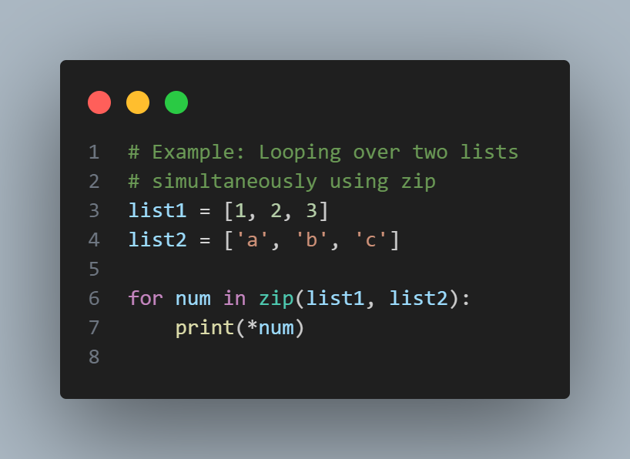

*Fig 1 (zip function example)*

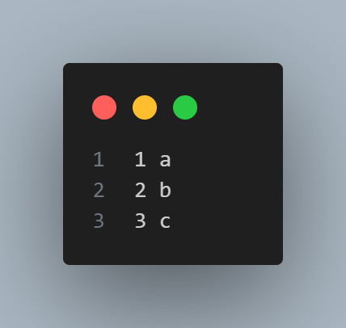

*Fig 1 output (zip function example)*

In this example, zip pairs elements from list1 and list2 into tuples (1, 'a'), (2, 'b'), and (3, 'c'), allowing me to iterate over both lists simultaneously. Similarly, tuples can be useful in loops over dictionaries, especially when you need both the key and value during iteration.

**Using The Item method in dictionary:**

The items method of dictionaries returns a sequence of tuples containing key-value pairs.

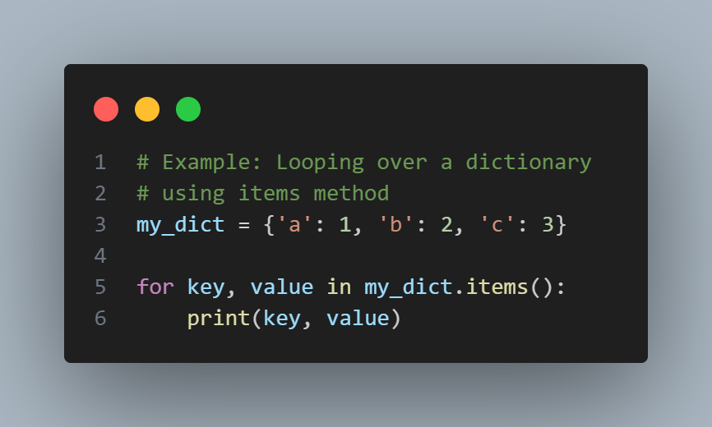

*Fig 2 (dictionary and item method)*

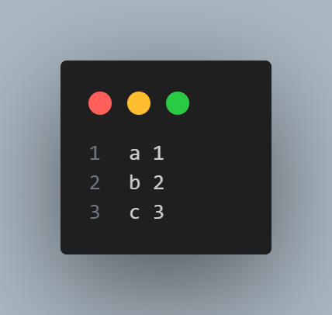

*Fig 2 output (dictionary and item method)*

In this example, items() returns tuples ('a', 1), ('b', 2), and ('c', 3), allowing me to iterate over keys and values simultaneously.

**Using the Enumerate Function:**

The enumerate function is useful when you need both the index and value of elements in a sequence. It returns tuples containing the index and value of each element. The result from enumerate is an enumerate object, which iterates a sequence of pairs; each pair contains an index (starting from 0) and an element from the given sequence Downey, A. (2015,). Think Python: How to think like a computer scientist ,*Chapter 12.5 List and Tuples (pp 119),*

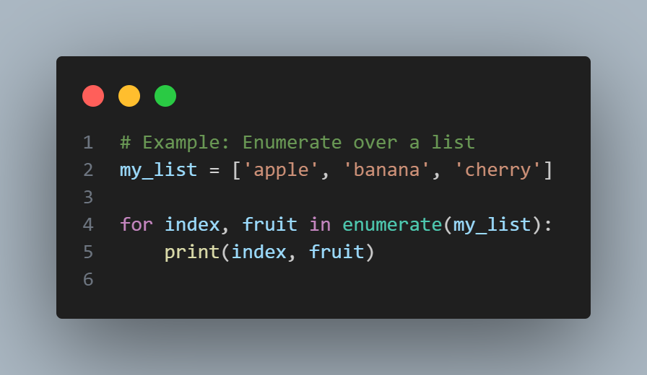

*Fig 3 (enumerate method)*

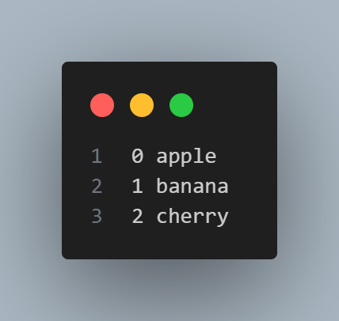

*Fig 3 (enumerate method)*

In this example I used the enumerate method which returns tuples (0, 'apple'), (1, 'banana'), and (2, 'cherry'), allowing me to access both index and value during iteration.

**References**

Downey, A. (2015,). Think Python: How to think like a computer scientist ,*Chapter 12.5 List and Tuples (pp 119)*

<https://greenteapress.com/thinkpython2/thinkpython2.pdf>